Note: This document is “view only”. Please create a copy of this document and save it to your drive.

**SOP - Merging Duplicate Contacts- Systems Vault**

**PREREQUISITES**

[Master: SOP- Operations Management -Systems Vault](https://docs.google.com/document/u/0/d/1gIeHLaKTWivg43RAx2fHPd14QktmUju8dcElYWywAXM/edit)

[Ontraport](http://sarahnoked.com/ontraport)

http://members.sarahnoked.com/wp-admin

[Teamwork PM](http://sarahnoked.com/teamwork)

**PURPOSE**

Merging duplicate contacts allows you to search for duplicates in our Contacts and combine them into a single Contact record. You choose which Contact fields to keep from each of the duplicates, as well as all the Tags and Sequences to which the merged Contact will be subscribed. This process ensures that our list is healthy and that we keep sending emails to duplicate contacts at a minimum.

**POLICY**

This is a recurring task in [Teamwork PM](http://sarahnoked.com/teamwork)  that happens once a week.

Note that there are many contacts with the same IP Address of 0.0.0.0 and 127.0.0.1. In situations like this only merge the contacts if you see the same first and last name in the First Name/Last Name/Email Address for fields

Important things to note

* If both contacts are on the same Sequence the merged Contact will be subscribed to the Sequence on the latest step (no step is repeated)
* Open Orders (including subscriptions and payment plans) are merged
* Sales, payment and transaction history can be merged
* The credit card with the last successful transaction will be merged
* Tags the contacts are subscribed to can be merged. Including access tags to membership site.
* Take note of all contacts with just a letter as their First Name (eg: D Gaviola) and/or any contacts spelled in all caps.
  + If they only have a letter as their first name, look at their email address and see and analyze if their first name could be on their email address and edit the name accordingly. For example, a contact’s name is D Gaviola and when you checked their email, it says draygaviola@gmail.com. Change “D” on the first name field to “Dray”.
  + If their name is in all caps, make sure to edit them so that they have proper capitalization

**PARTY**

Tech VA

**PROPERTY**

Online Business Manager

**PROCESS**

Part 1: Review contacts with first name and last name

Part 2: Merge duplicate contacts

Part 3: Review contacts with similar IP addresses

Part 4: Merge duplicate contacts

Part 5: Review contacts with same email address

Part 6: Merge duplicate contacts

Part 7: Update Accessally users in members area

**PROCEDURE**

**Part 1: Review contacts with the same first name and last name fields**

1. Access [Ontraport](https://ontraport.com/)
2. Click on Contacts > Settings 
3. Choose 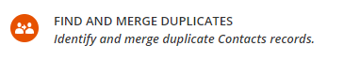
4. Choose to search duplicate fields by clicking   **“first name”**
5. Choose to search duplicate fields by clicking   **“last name”**
6. Click 

**Part 2: Merge duplicate first name and last name field contacts**

1. Check off one pair of matching contacts (note you can only merge one contact at a time)

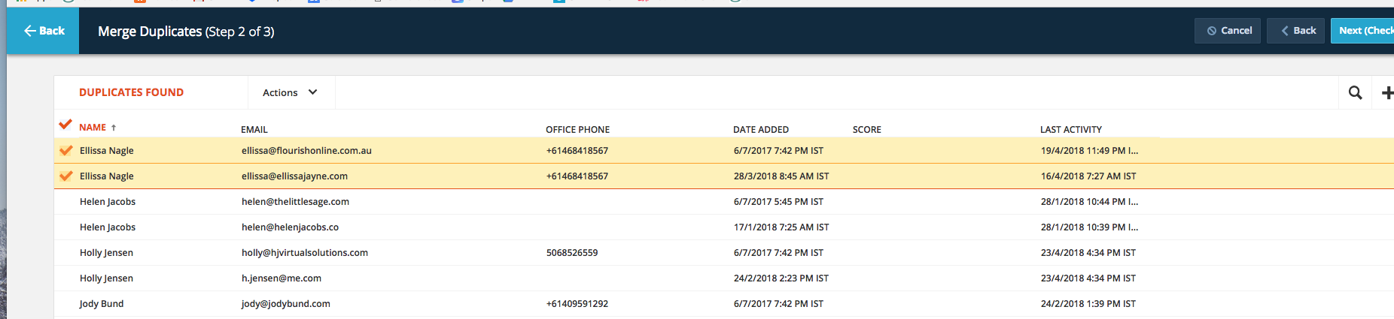

* 1. Click on Next 
  2. Under 
     1. If the person has an accessally password, click **“replace all”** on the column with the access ally deets, so that the contact record retains the accessally login email address and password, click on **“combine all”** from the other side (this is to ensure all tags, purchased and details get retained)
     2. If the person does not have an AccessAlly account, look at what the person used to purchase. This is often the “best” email address
        1. Tip: AccessAlly account identifier is when the contact has AA_password field
     3. If the person does not have an accessally account and has never made a purchase with us before, use your judgement to decide which email address should be used. We usually prefer retaining the business email of the contact than the gmail/personal one.
  3. Once you're done reviewing all form fields and replaced/combined, click on 

1. Repeat for all contacts

**Part 3: Review contacts with same IP Address**

1. Access [Ontraport](https://ontraport.com/)
2. Click on Contacts > Settings 
3. Choose 
4. Choose to search duplicate fields by clicking   **“ip address”**
5. Click 

**Part 4: Merge duplicate ip address field contacts**

1. Check off one pair of matching contacts (note you can only merge one contact at a time)



* 1. Click on Next 
  2. Under 
     1. If the person has an accessally password, click **“replace all”** on the column with the access ally deets, so that the contact record retains the accessally login email address and password, click on **“combine all”** from the other side (this is to ensure all tags, purchased and details get retained)
     2. If the person does not have an accessally account, look at what the person used to purchase. This is often the “best” email address
     3. If the person does not have an accessally account and has never made a purchase with us before, use your judgement to decide which email address should be used
  3. Once you're done reviewing all form fields and replaced/combined, click on 

1. Repeat for all contacts

**Part 5: Review contacts with same email address**

1. Access [Ontraport](https://ontraport.com/)
2. Click on Contacts > Settings 
3. Choose 

Choose to search duplicate fields by clicking   **“email”**

Click 

**Part 5: Merge duplicate email address field contacts**

1. Check off one pair of matching contacts (note you can only merge one contact at a time)



* 1. Click on Next 
  2. Under 
     1. If the person has an accessally password, click **“replace all”** on the column with the access ally deets, so that the contact record retains the accessally login email address and password, click on **“combine all”** from the other side (this is to ensure all tags, purchased and details get retained)
     2. If the person does not have an accessally account, look at what the person used to purchase. This is often the “best” email address
     3. If the person does not have an accessally account and has never made a purchase with us before, use your judgement to decide which email address should be used
  3. Once you're done reviewing all form fields and replaced/combined, click on 

2. Repeat for all contacts

**Part 7: Update Accessally users in members area**

1. Login to [members.sarahnoked.com/wp-admin](https://members.sarahnoked.com/wp-admin/)
2. Check for the warning: Some users have invalid contact ID. 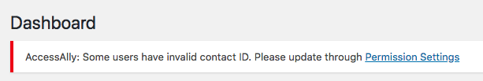
3. Click on the link to Permission settings
   1. In AccessAlly > Permissions > Update Users, scroll to the bottom of that page. There, you will see a section titled “Update users with invalid contact ID by matching email”.
4. Click the yellow START UPDATE button.

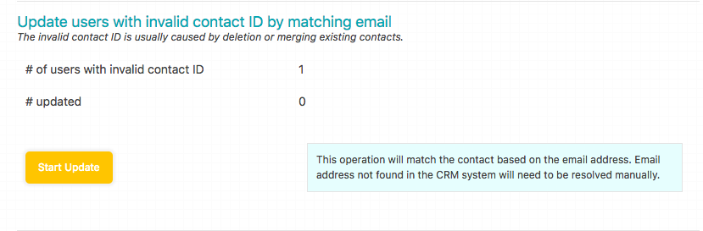

5. If this does not resolve the issue, you will see the invalid Contact ID users appear, along with the reason why the error exists.

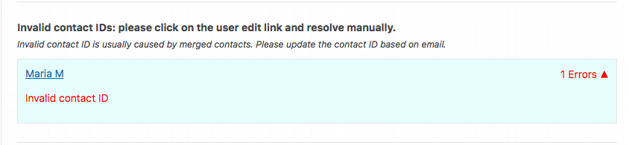

IMPORTANT: In this case, delete the contact ID. If the contact ID is from Sarah, leave it.

**Created by:**

**Department:** Operations & Support

**Date:**

**Revised:**

**Revised By:**